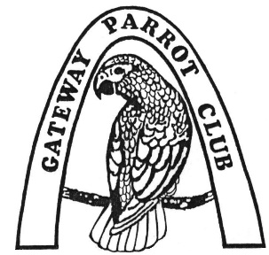
The Gateway Parrot Club
Membership Application
Please complete this form and forward it to our Membership Secretary. You may do this by postal mail to the address below or bring it to a meeting. We normally meet every 3rd Sunday of the month at 2:00 pm at Varietees Exotic Bird Store, 60 Meramec Valley Plaza, Valley Park, MO 63088. (Check website for possible schedule changes). We look forward to seeing you.
(Please print clearly)
Date
Name (First / Last)
Mailing Address Street
City
State
ZIP
Primary phone | Home  Work  Cell 
Secondary phone | Home  Work  Cell 
Other family members
How did you hear about us?

Email is an important communication tool for us. If you use email, please include your address below and indicate what information you would like to receive and in what format. Your email address will only be used for Club business. Circle your choices. If unsure, leave blank and we will use the value in Bold.
(Please print clearly)
Email address
How would you like to receive the GPC Newsletter? | ❑ Email  Postal Mail  MISSION STATEMENT  To bring people together in a friendly atmosphere in the interest of exchanging information on bird care and breeding.  To create interest in bird care and responsible breeding through monthly educational programs and annual bird fairs.  To reduce neglect, cruelty and abuse of captive birds through education and public outreach.  To educate the public, as well as ourselves, on the ever present danger of extinction in the wild.  Check One
Annual dues are $20 per household. Renewal is due
by December 31 for each subsequent year.
Make checks payable to Gateway Parrot Club
Mail this form with payment to: Gateway Parrot Club
P.O. Box 222
Valley Park, MO 63088

You can also complete this form and pay online at our website:
www.GatewayParrotClub.org

